STAY SAFE IN THE UK
English Web Pack

All hyperlinks are set to open in a new tab
All images will be sent in a separate Zip file

Page Title: STAY SAFE IN THE UK
Subtitle: Below you will find a directory of information on where you can find support in the UK if you are Ukrainian and have been displaced because of the conflict.
Introduction/Call to action: If you are in immediate danger, please call the emergency services in the UK on 999. We are keeping this page up to date as more resources are available in Ukrainian and more services become available.

BLOCK 1:
Title: Scroll down for information on…
Image:
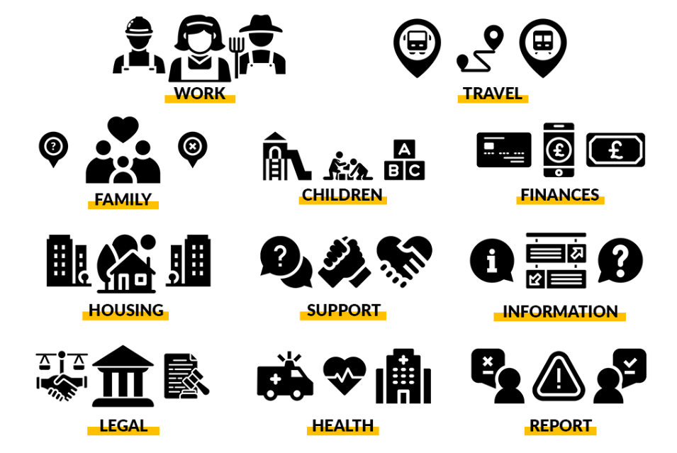

BLOCK 2:
Title: Work
Introduction: Know your workers’ rights in the UK and how to find work.
Image:

Text: You have the right to safe work in the UK.

You should not have to experience any of the following at work:
- Not been paid for your work
- Being withheld your wages
- Being denied breaks and/or annual leave
- Restricted movement
- Restricted or no access to your earnings
- Being subject to intimidation, coercion, and/or physical or emotional abuse
- No access to your personal documents
- Excessive working hours
If you have experienced any of the above, know this should not be tolerated and there are organisations that can help you.
Here are some useful links (setting: open link in new tab):
- Work Rights Centre: Solidarity with Ukraine
- Information on Worker Rights in the UK
- Just Good Work Application
- Working in the UK - Your Rights (Ukrainian)

BLOCK 3:
Title: Housing
Introduction: How to find accommodation and where to report issues with where you are staying.
Image: 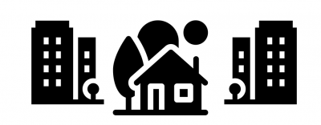

Text: You have the right to a safe place to stay.

You have the right to stay somewhere that:
- be kept clean and in a reasonable state;
- have adequate kitchen and bathroom space;
- have access to drinking water;
- have a working smoke detector on each floor of the property and other fire safety precautions suitable for the building e.g. fire doors or escape routes as appropriate
- have a working carbon monoxide detector in any room containing a solid fuel burning appliance (e.g. a coal fire, wood burning stove);
- have sufficient heating to keep the property at a comfortable temperature;
- be almost entirely free of damp or mould;
- have doors and windows at entry level that lock properly;
- be easy and safe to move around in

Wherever you are staying you have the right to choose to stay somewhere where:
- you are not asked to do anything that makes you feel unsafe
- asks you for favours, money or anything in return for free accommodation

BLOCK 4:
Title: Health
Introduction: Physical and Mental Health support and your access to healthcare in the UK.
Image:

Text: You have the right to free healthcare in the UK.
Medical treatment for Ukrainian refugees in the UK is free including GP and nurse consultations, hospital services, and urgent care centres.
If you need non-emergency healthcare please call 111 which is a free NHS healthcare line.
Here are some useful links:
- To find your nearest GP service and for more information click here.
- For first aid guidance resources in Ukrainian and Russian from St John Ambulance click here.

COVID-19:
Coronavirus (COVID) Vaccines:
The majority of people in the UK have received at least one of their coronavirus vaccine and it is likely that all adults in your hosts household will have received theirs. For the latest guidance on what to do if you have or suspect you have the virus, please visit the UK Government’s COVID-19 advice webpage here.
Booking a coronavirus vaccination
You are eligible for a free COVID-19 vaccination through the NHS. If you are registered with a GP, you can book your vaccination through this web link if you are in England ‘
'Walk in’ sites are also available and able to offer help to those who have not yet registered with a GP. A list of locations can be found here. If you are in Scotland, click here.
If you have already had a Covid-19 vaccine in Ukraine or elsewhere, speak to your GP about which further doses you should have in the UK and when you should have them.
You should also tell the NHS about any Covid-19 vaccinations that you have had outside of the UK. This is so the NHS can update your vaccination record. Bookings to make an appointment to get your previous vaccinations recorded can be made online using the National Booking Service or by calling 119. 119 will also have translators available.

BLOCK 5:
Title: Legal
Introduction: Find access to legal advice, such as immigration advice.
Image:

Text: You have the right to Legal advice.
If you are earning less than £8,000 a year or on certain benefits then you have the right to free legal support in the UK.
You can get legal advice on many topics, such as immigration, modern slavery, debt, education, family, benefits, housing and crime.
Click here to read free immigration advice for Ukrainians entering the UK.
You can find a legal aid solicitor here.
The page is currently in English so you will need the post code of where you are staying alongside someone to translate or interpret for you, if required.

BLOCK 6:
Title: Family
Introduction: Support to find family that has been displaced because of the conflict.
Image:
Text: You may have lost contact with your family or those displaced.
If you have lost contact with your family due to the recent conflict escalation in Ukraine, or you know your family has left Ukraine and crossed the border, please keep trying to contact them as this may be a temporary loss of contact as they transition to networks in other countries.
If you are unable to contact your family and you think they are still within the territory of Ukraine, we may be able to help you:
Please email findyour_family@redcross.org.uk and provide us with your full name and telephone number. A team member from the International Family Tracing service will contact you as soon as possible.

BLOCK 7
Title: Finances
Introduction: Information on benefits and financial support in the UK.
Image:

Text: You have the right to financial support if you cannot work, or find work.
The UK has a welfare system which is designed to help those who face financial hardship, or who have specific needs. Your local Job Centre Plus will be able to help you find out which benefits you may be able to access. This may include:
- Universal Credit: a payment for those of working age, to help with your living costs if you’re on a low income. You could be working (including self-employed or part time) or be out of work.
- Pension Credit: extra money to help with your living costs if you are over the age of 66 and on a low income. Applications for Pensions is online or via telephone.
- Disability benefits: extra money to help with additional costs if you have a long term physical or mental health condition or disability .
- Carer’s Allowance: extra money if you care for someone at least 35 hours a week.
- Child Benefit: extra money to help with the cost of raising a child.
A link to the different types of benefits you could receive can be found here.
If you are in Scotland advice can be found here.
Citizens Advice also provides free advice on dealing with banking, debt, bankruptcy, and more. You can find your local Citizens Advice Bureau here if you are in England and Wales, here if you are in Scotland, and here if you are in Northern Ireland.

Opening a Bank account
There are a range of banks, and you can choose one that suits you best. There are also online-only providers which you can use.
The safest way to do this in your local bank branch rather than online so as to avoid any potential scams.
To open a bank account in the UK, you usually need to show proof of ID such as passport, biometric residency permit, driver’s licence or recognised identity card. You also need proof of permanent address. The Government is working with major banks to find a solution to enable you to open accounts without the usual permanent address requirement. A number of UK banks already have a system for opening accounts where you do not have a permanent UK address. You may need to get the help of a local charity or your local authority to help you do this.

BLOCK 8
Title: Children
Introduction: Information on support for your family and children.
Image: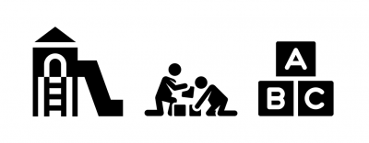
Text: To find out more about support for families and children in English and Ukrainian click here.

BLOCK 9
Title: Travel
Introduction: Information about travel in the UK.
Image: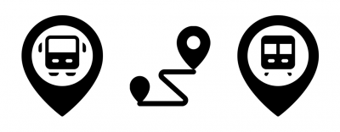

Text: Here are 8 things to remember to keep yourself safe:
1. Travel in a group.
2. Make sure you tell someone you trust about the trip you are taking.
3. If someone in your group goes missing, tell the police immediately.
4. If you are under 18 and travelling alone make sure your family knows where you are every step of the way.
5. If someone offers you transportation, take a picture of them and their ID, their vehicle and registration and share it with your friends/family.
6. Always keep your ID, travel, and personal documents safe – never give them away only show them to officials if you need to.
7. Save emergency numbers on your mobile phone and always keep it with you.
8. People may offer you work, make sure you know the address of the workplace, share it with friends/family.
There are 12 major entry points to the UK, where there will be designated areas (Welcome Points) for you to meet your sponsor and where you can seek support, including to arrange your onward travel. These are established in Heathrow, Gatwick, Stansted, Edinburgh, Birmingham, Manchester, Luton, Bristol, Bournemouth, and East Midlands airports; Dover & Folkestone Port Authority; and St Pancras Station in London.
If you have agreed with your Sponsor that you will make your own way to their home, you will be eligible for a single onward journey via national rail, bus, light rail and coach, free of charge to your destination anywhere in England, Scotland and Wales.
There is an extensive train and bus network across the UK, particularly in cities and urban areas. For national trains or buses, tickets are usually much cheaper if bought in advance. You can find out more information on the national rail website here.
You don’t need to show identification to travel within the UK unless you are travelling by plane.

BLOCK 10
Title: General Information
Introduction: Here is some more information on life in the UK.
Image:
Text: You can find a comprehensive document on life in the UK here. You can also read it in Russian and Ukrainian.
This document covers:
- Arriving in the UK
- Getting used to life in the UK
- What to do if things go wrong
- Legal Rights and Responsibilities
- Applying for a School place in England
- Quick Guide to Key Services

BLOCK 11
Title: Support
Image:

Text: There are a number of organisations and groups that can support asylum seekers and Ukrainians in the UK.
Click on the pages below to find out more:
- British Red Cross Local Refugee Services
- Association of Ukrainians in Great Britain
- City of Sanctuary Groups

BLOCK 12
Title: Report
Introduction: How to report concerns of trafficking or incidents of exploitation.
Image: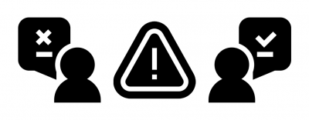

Text: You have the right to report and seek support if something has gone wrong.
If you are in immediate danger call – 999, this line covers health emergencies, fire and police services, you can request an interpreter on this line.
If you believe you have exploited or are worried someone else in exploitation call the modern slavery helpline on 08000 121 700.
To report a crime or information relating to a crime please call Crimestoppers on 0800 555 111.
If you have seen something that doesn’t quite look right or have experienced exploitation in the UK and want to anonymously share your story – download the STOP APP – available on Ios and Android and in Ukrainian.
There are also many trusted NGOs and support organisations in the UK that you can find in your local community and that we will continue to update here.

BLOCK 13
Title: More Information and Resources
Text: For a full list of resources available, including resources in English for those supporting people displaced from Ukraine please click here: Further Resources for Displaced People from Ukraine
Do you have a translated (Ukrainian) document or support organisation that you believe should be listed on this page? Get in touch with us at info@stopthetraffik.org.
This page includes resources gathered by a collaboration of charities providing support, protection and prevention for those arriving from Ukraine to the UK. We would really value your feedback as we continue to develop this page so that we can meet as many needs as possible. You can reach us at info@stopthetraffik.org or info@hopeforjustice.org.

Built in collaboration

